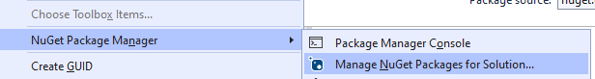

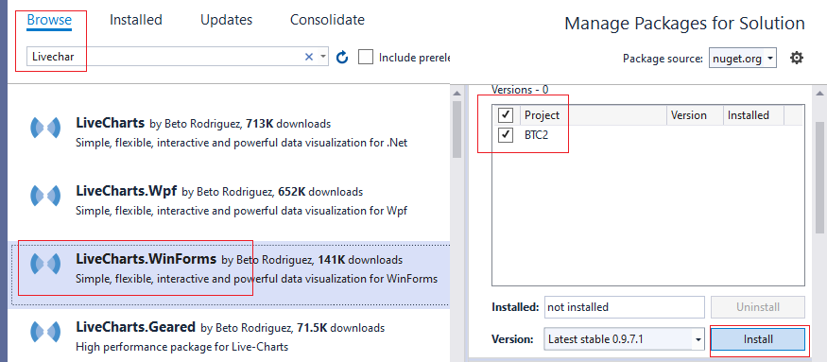

Si no se pudo instalar es porque debe usar Framerowk 4.8

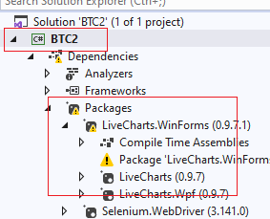

Se va a projecto, escoge Properties

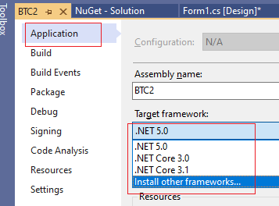

**public** **class** Revenue

{

**public** **int** Year { **get**; **set**; }

**public** **int** Month { **get**; **set**; }

**public** **double** Value { **get**; **set**; }

}

revenueBindingSource.DataSource = **new** List<Revenue>();

Chart1.AxisX.Add(**new** LiveCharts.Wpf.Axis

{

        Title = "Month",

        Labels = **new**[]

{ "Jan", "Feb", "Mar", "Apr", "May", "Jun", "Jul", "Aug", "Sep", "Oct", "Nov", "Dec" }

});

Chart1.AxisY.Add(**new** LiveCharts.Wpf.Axis

{

        Title = "Revenue",

        LabelFormatter = value => value.ToString("C"

});

Chart1.LegendLocation = LiveCharts.LegendLocation.Right;

  Chart1.Series.Clear();

    SeriesCollection series = **new** SeriesCollection();

    var years = (from o **in** revenueBindingSource.DataSource **as** List<Revenue>

                 select **new** { Year = o.Year }).Distinct();

**foreach** (var year **in** years)

    {

        List<**double**> values = **new** List<**double**>();

**for** (**int** month = 1; month <= 12; month++)

        {

**double** value = 0;

            var data = from o **in** revenueBindingSource.DataSource **as** List<Revenue>

                       where o.Year.Equals(year.Year) && o.Month.Equals(month)

                       orderby o.Month ascending

                       select **new** { o.Value, o.Month };

**if** (data.SingleOrDefault() != **null**)

                value = data.SingleOrDefault().Value;

            values.Add(value);

        }

        series.Add(**new** LineSeries() {

Title = year.Year.ToString(),

Values = **new** ChartValues<**double**>(values) });

    }

Chart1.Series = series;